Testing for CHS Calculus:
Information for Students and Parents

Overview
College-level mathematics courses can be a challenge even for well-prepared students. Students without the needed prerequisite skills are likely to experience frustration and failure. We want students to succeed!
The Mathematics placement assessment will help you determine whether you are ready for a college level calculus course. All prospective students in entry-level Pitt calculus courses, whether through CHS or on-campus, must attain a required minimum score in the math assessment before enrolling.
The ALEKS system (see aleks.com) that the University of Pittsburgh uses is an adaptive online assessment which provides a detailed evaluation of precalculus skills. An additional benefit is that ALEKS provides individualized tutoring through Prep and Learning Module to help students improve their skills. Students who do not attain the required minimum placement score can repeat the placement assessment after working through the ALEKS Prep and Learning Module.
Please note that the requisite ALEKS score does not automatically qualify students to take the CHS course—they must also meet the criteria set by the high school.

Cost
There is a fee of $25 for the ALEKS placement assessment. The fee covers up to three attempts at the placement assessment, as well as six months of access to the ALEKS Prep and Learning Module. Payment can be made by credit or debit card at the time of the initial assessment.
A student who demonstrates financial need can have the fee waived by contacting his or her high school teacher.

School-Specific Information

Teachers: Please delete this text and insert school-specific information such as how students will take the test (for example, in school or at home) and the deadline you will set for students to earn the required placement test score.

1. Overview
The Mathematics placement assessment will help you determine whether you are ready for a college-level calculus course.
The assessment will take approximately 90 minutes to complete. After the assessment, a targeted Prep and Learning Module is available for you to review and learn material, and to improve placement and eventual course outcomes.
You are strongly encouraged to spend several hours using the ALEKS Prep and Learning Module. Even if you have achieved the needed score for placement in your desired course, extra time spent in ALEKS will better prepare you for your upcoming course and ultimately lead to better grades.
While you are taking the assessment, do not consult any other source for help (friends, family, internet searches, etc.). The purpose of the placement assessment is to give an accurate measure of your current mathematical skills so that you will be successful in your mathematics courses.

2. Payment
There is a fee of $25 for the ALEKS placement assessment. The fee covers up to three attempts at the placement assessment, as well as six months of access to ALEKS learning modules, which will help you hone your skills. You can pay with a credit or debit card at the time of your initial assessment.
Students who demonstrate financial need, as determined by CHS, can have the fee waived. If you are receiving a free or reduced-price lunch or face another circumstance that makes payment difficult, please ask your teacher for a CHS Financial Assistance Form.

3. The Evaluation
1. Go the ALEKS Web site www.aleks.com.
2. Click the Sign Up Now button.
3. Enter the course code RXYRW-FMAKP and click Continue.
4. At the screen asking you to confirm enrollment for CHS placement, click Continue.
5. If this is your first ALEKS login for the CHS placement assessment, click the button next to “I have never used ALEKS before or I do not have an ALEKS login name,” and then click Continue.
6. Most students will click the “Purchase access online” link and proceed to purchase access by credit card. If you have an access code from CHS, you will instead click “I have non-ecommerce access” and enter your access code.
7. On the Student Registration page, enter all requested information. For student ID#, please enter a random string of 10 digits.
8. Save your login name and password. You will need them to sign into ALEKS.
9. Take the informational survey and exam.
10. Give a printout of your final score to your teacher.

4. FAQs
Who has to take the ALEKS Placement Assessment?
All students who will take the University of Pittsburgh Business Calculus (MATH 0120) or Analytic Geometry & Calculus 1 (MATH 0220) course, either on campus or through CHS, must take the placement assessment.
How will I take the placement assessment?
Your teacher will tell you how to take the ALEKS placement assessment, which is an unproctored online test.
When should I take the placement assessment?
Your teacher will tell you when you should take the placement assessment.
Can I retake the ALEKS Placement Assessment?
Yes, you may take up to 3 placement assessments. However, to make each attempt worthwhile, it is important that you spend time working in your ALEKS Prep and Learning Module in between placement assessments so that you can improve your skills.
Can I retake the ALEKS Placement Assessment immediately?
You must wait 48 hours between placement assessments. There is generally no benefit to re-taking the assessment immediately after completing a prior attempt. Unlike the SAT or ACT, you cannot improve your results by simply re-taking the assessment without spending time in the Prep and Learning Module to refresh material that you may have forgotten or to learn new material.
Must I work in my ALEKS Prep and Learning Module between placement assessments?
Yes, after completing the assessment, you must spend a minimum of 5 hours in your Prep and Learning Module before repeating the assessment.
Are placement assessments timed?
Yes, you have 24 hours to complete a placement assessment once it has begun.
How long will a placement assessment take to complete?
Placement assessments require approximately 90 minutes to complete, but the amount of time will vary by student. There will be a maximum of 30 questions.
May I use a calculator while using ALEKS?
ALEKS will provide an on-screen calculator if you need one to complete a particular problem. Otherwise, you may not use a calculator.
When should I use the “I do not know” button?
Never click the “I don’t know” button during any ALEKS assessment unless you really don’t have any idea of how to do the problem. Otherwise, ALEKS will think you don’t know many of things you actually do know, and it will take you way back and make you “learn” them.
What happens if I do not complete a placement assessment within the 24-hour time limit?
You will have to restart the assessment.
Can I practice using ALEKS before I begin placement?
ALEKS will begin with a brief tutorial before your placement begins.
May I use any other resources during a placement assessment?
You may only use a pen or pencil, paper, and the resources provided by ALEKS. You may not receive assistance from friends, family, or anything not provided by ALEKS. If you are dishonest on this placement test, you could be placed into a course that you could ultimately fail.
What is my placement result?
Your placement result will be a numerical score. A minimum placement score of 61 is required for enrollment in Business Calculus (MATH 0120). A minimum score of 76 is required for enrollment in Calculus 1 (MATH 0220).
How long do I have access to my Prep and Learning Module?
You will have six months of access from the time that you start using your Prep and Learning module.
Is there an additional fee for my Prep and Learning Module?
No. The $25 access fee covers six months of access to the Prep and Learning Module and up to three attempts at the placement assessment.
What are ALEKS Progress Assessments?
While working in a Prep and Learning Module, you will periodically complete progress assessments to solidify your gains in knowledge.

Does progress in an ALEKS Prep and Learning Module count toward placement?
No, you must complete a new placement assessment to change your placement result. Click on the placement tab on the upper right of the page from within ALEKS. Only your placement assessment results will be used for course placement.
What if I do not place into the course that I wanted?
You can use a Prep and Learning Module to review and learn, and you may take another placement assessment to improve your placement result.
I did not place into the class I wanted. Can I sign up for the Pitt credits anyway?
No, you must achieve the minimum placement result to register for the Pitt credits. Your high school might allow you to take the course for high school credit, based on its policies.
What if I placed into the class that I wanted?
Congratulations! Continue to use your Prep and Learning Module to improve your chances for success. The required placement score is the minimum preparation required for your course! Take advantage of the targeted review and learning features in ALEKS to get a better grade in your class.
Where can I get help with ALEKS?
www.aleks.com/faqs/technical or support.aleks.com
Can I use ALEKS with Linux?
Yes, but you will have to install the required plugin manually. Follow these instructions: www.aleks.com/downloads/linux_jvm
How do I get my ALEKS placement score?
After you complete the assessment, you will be presented with a pie chart showing your areas of strength and weakness. An example of this page, which you will print out and give to teacher is shown at the top of the next page.
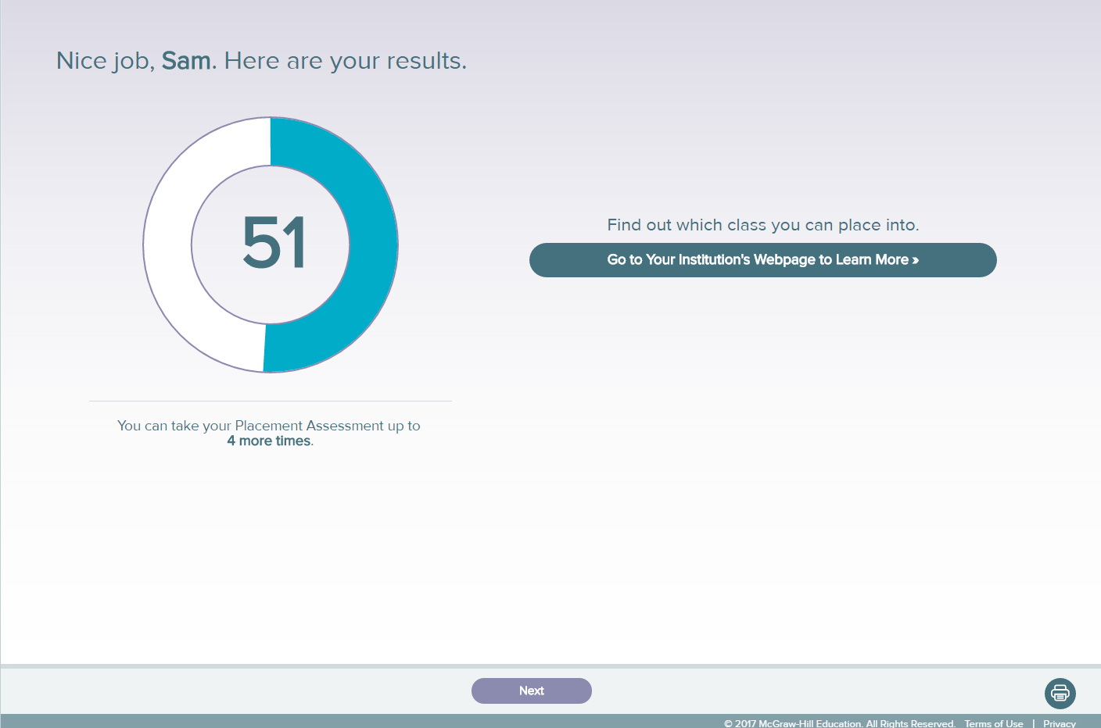
Your overall assessment score appears at the top of the page. If you take the assessment more than once, your scores from previous assessments will be shown below the pie chart, and your highest score will be used for placement purposes.
If you forget to print your assessment score, you can log into ALEKS again to review and print your scores.
How will my school get my ALEKS placement score?
They will get it from you! When you complete the assessment, print the ALEKS pie chart page with your placement score, and give it to the teacher for approval to register for the CHS course.
Does the requisite ALEKS score automatically qualify me to take the CHS course?
No. You must also meet the criteria set by your high school.
Will this ALEKS placement score be a part of my application if I decide to apply to the University of Pittsburgh?
If you attend the University of Pittsburgh, this ALEKS score may be used to determine your placement into future mathematics courses.

